|  |
| --- |
| **Expt no: 1 a CALCULATING ELECTRIC BILL**  **Aim:**  To draw Flowcharts and write algorithm for calculating Electric Bill.  **Algorithm:**  **Step 1:** Start  **Step 2:** Enter this month unit, previous month unit.  **Step 3:** Obtain Unit= This month Unit - Previous month unit.  **Step 4:** Check Unit<=100, if true, No amount to pay else move to next Step 5.  **4.1:** Calculate amount, Total charges.  **4.2:** Display the amount (Tot. amount) and go to Step 8.  **Step 5:** Check Unit>100 & Unit<=200, if true, proceed 5.1 else go to Step 6.  **5.1:** Calculate amount, Total Charges.  **5.2:** Display the amount (Tot. amount) and go to Step 8.  **Step 6:** Check Unit>200 & Unit<=400, if true proceeded 6.1 else go to Step 7.  **6.1:** Calculate amount, Total Charges  **6.2:** Display Total Amount and go to Step 8  **Step 7:** Check Unit>400, if true Proceed 7.1 else go to Step 8.  **7.1:** Calculate amount, DC, FC  **7.2:** Display Tot amount and go to Step 8  **Step 8:** Stop.  **Result:**  Thus the algorithm and flowchart is written for given program.  ROLL NO: 22CSE48  NAME: M.NANDHAKUMAR |

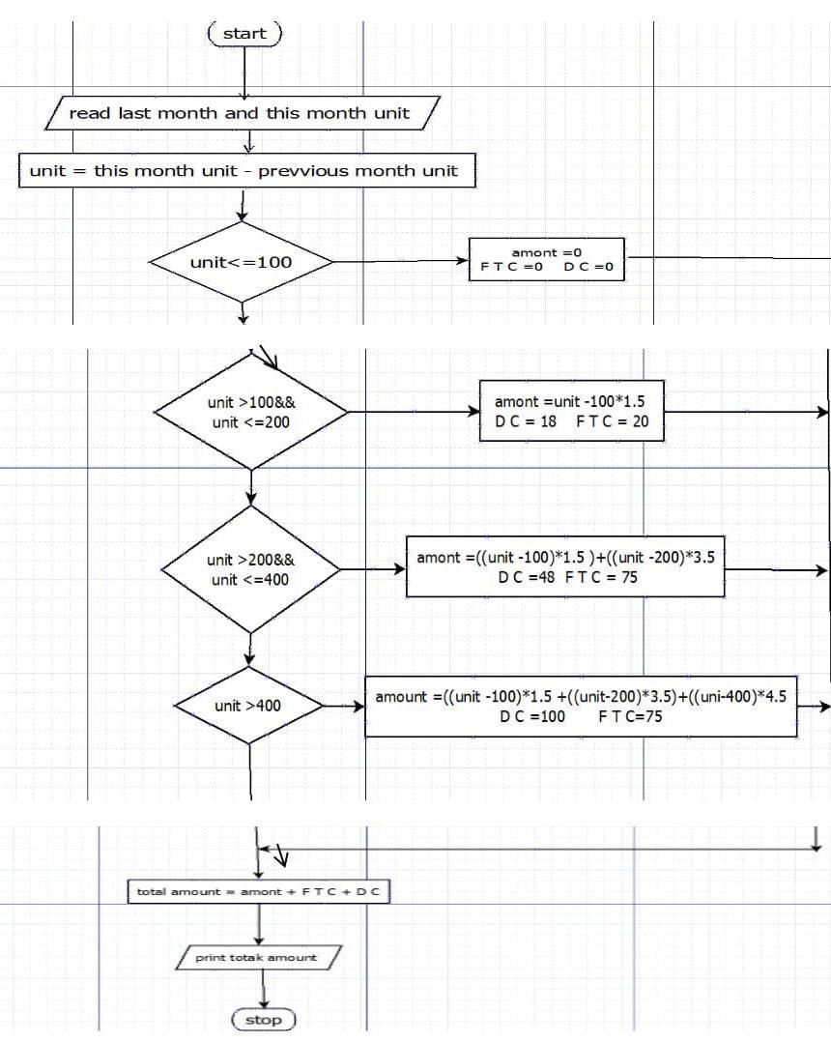

YES



YES



YES



YES



NO



NO



NO



NO

**Result:**

Thus the algorithm and flowchart is written for given program.

**Expt no: 1 b SINE SERIES**

**Aim:**

To draw flowchart an algorithm for the following problem [Sine Series] **Algorithm:**

# Step 1: Start

**Step 2:** Get the value of x

**Step 3:** Initialize the value of i=1, Sine=0 and import math

**Step 4:** Get the value of N

**Step 5:** Check the value of i is less than N

**5.1:** If condition is true, convert x to radian and adding i to Y

Y=Y+X*(3.146/100)

**5.2:** Let the value of S be (-1) to the power i

**5.3:** Now calculate sine series using formula Sum = [[(-1) **i]*[x**(2+i)(2i+1)1]]!

**5.4:** Increment value of i by 1, go to Step 5

**5.5:**  If condition is false, display sine.

# Step 6: Stop

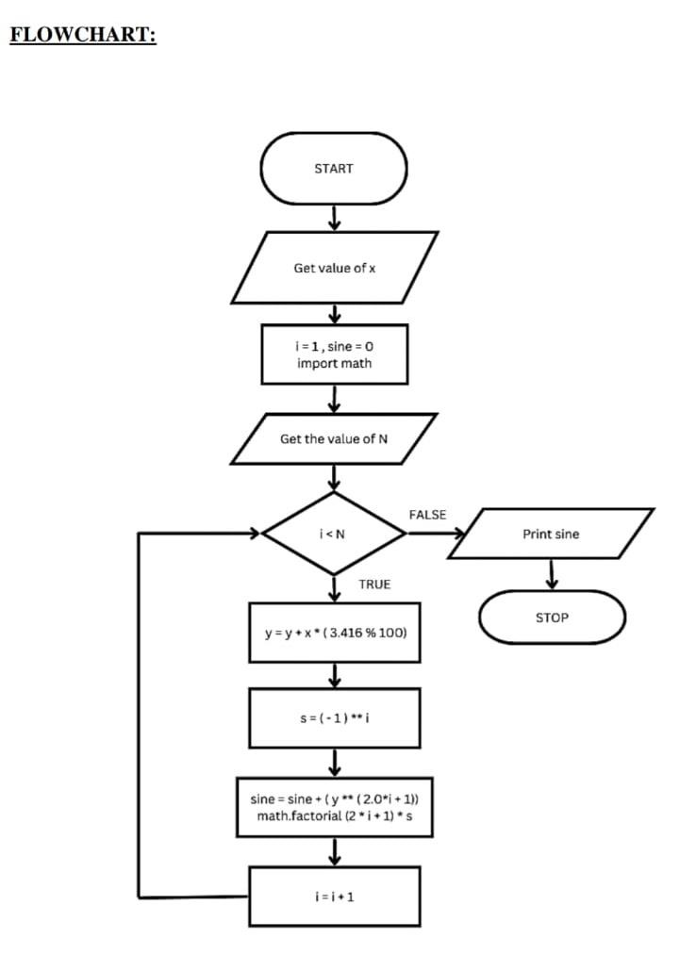

**Result:**

Thus the flowchart and algorithm is written for the given problem.

# Expt no: 1 c Calculate Electric Current inthree phase AC Circuit

**Aim:**

To draw flowchart and write algorithm for the given problem.

**Algorithm:**

**Step 1:** Start

**Step 2:** Get value of PF(Power Factor)

**Step 3:** Get value of current(I)

**Step 4:** Get value of voltage(V)

**Step 5:** Calculate P using the formula

P=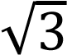*PF*I*V

**Step 6:** Display the Value of P

**Step 7:** Stop

**Result:**

Thus the flowchart and the algorithm is written for the given problem.

**Flowchart:**

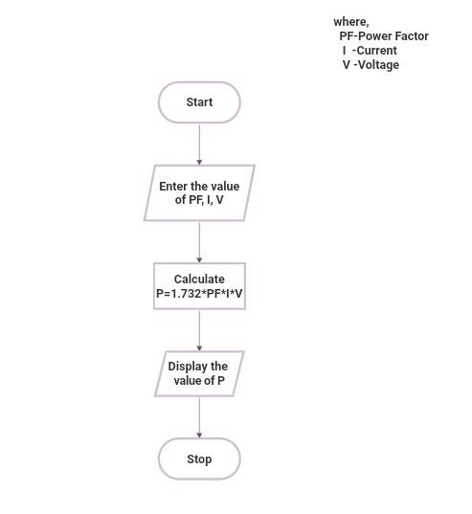

**Result:**

Thus the algorithm and the flowchart is written for the given problem.

# Expt no: 1 d Calculate weight of Steel Rod

**Aim:**

To draw flowchart and write algorithm for calculating the weight of a Steel rod.

**Algorithm:**

**Step 1:** Start

**Step 2:** Get the no of iron rods

**Step 3:** Initialize value i and weight as 0.

**Step 4:** Check for condition i=n

**4.1:** If true, get the diameter of the rod

**4.2:** Calculate the weight, Unit Weight using the formula,

d*d/162=W

**4.3:** Calculate the weight using the Formula,

No. of rods*Weight=TW

**4.4:** Calculate total weight= TW+W

**4.5:** Increment the value of i by 1, go to step 4

**4.6:** If false display the total weight

**Step 5:** Stop

**Flowchart:**

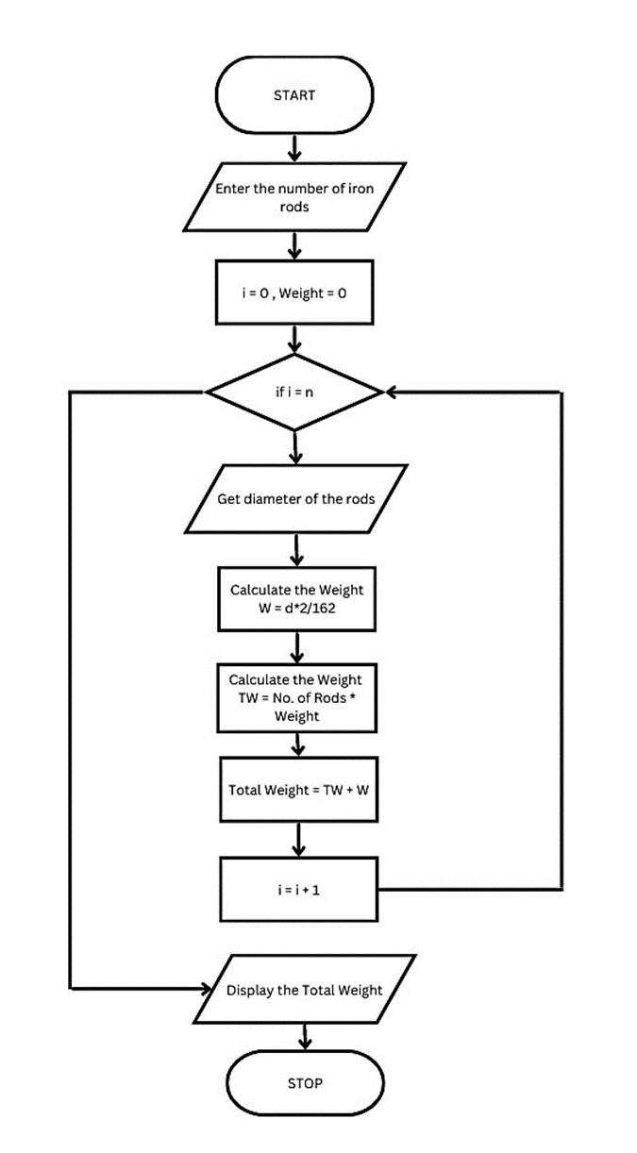

**Result:**

Thus the algorithm and the flowchart is written for the given problem.

# Expt no: 1 e Retail Bill Shopping

**Aim:**

To draw flowchart and write algorithm for the following problems.

**Algorithm:**

**Step 1:** Start

**Step 2:** Get the Bill number

**Step 3:** Get Customer name, Addr and Ph.no

**Step 4:** Get the Value of total no. of items purchased

**Step 5:** Initialize the values for i=0, Total=0, Subtotal=0

**Step 6:** Check if condition, i<=n

**6.1:** If true, get item name, price, Qty and discount

**6.2:** Calculate the Subtotal=Qty*Price-Discount

**6.3:** Calculate the Total=Total+Subtotal

**6.4:** Increment the value of i and go to Step 6

**Step 7:** If false, get the GST value

**Step 8:** Calculate Tot_bill_amount=(Total+GST)/100

**Step 9:** Display Tot_bill_amount

**Step 10:** Stop

|  |
| --- |
| **FLOWCHART:** |

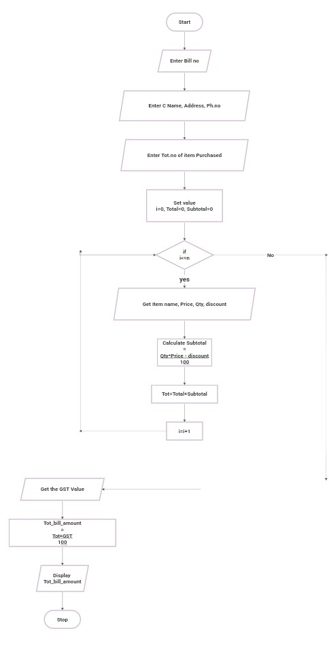

**Result:**

Thus the algorithm and the flowchart is written for the given problem.

# Expt no: 1 f Weight of a Motorbike

**Aim:**

To draw flowchart and write algorithm for the given problem

**Algorithm:**

## Step 1: Start

**Step 2:** Get Gross Vehicle Weight Rating GVWR

**Step 3:** Get Dry Weight DW

**Step 4:** Get Fuel Weight FW

**Step 5:** Get Rider Weight RW

**Step 6:** Get Passenger Weight PW

**Step 7:** Calculate Total Weight=DW+FW+RW+PW

## Step 8: Get load

**Step 9:** Calculate Safe Weight = GVWR – Load Weight

**Step 10:** Check the condition, Safe weight>=0

**10.1:** If true, print the message “You have a Safe load and you can drive” go Go to step 11

**10.2:** If false, Print the message “Reduce the load and then drive” go Step 8

## Step 11: Stop

**Flowchart:**

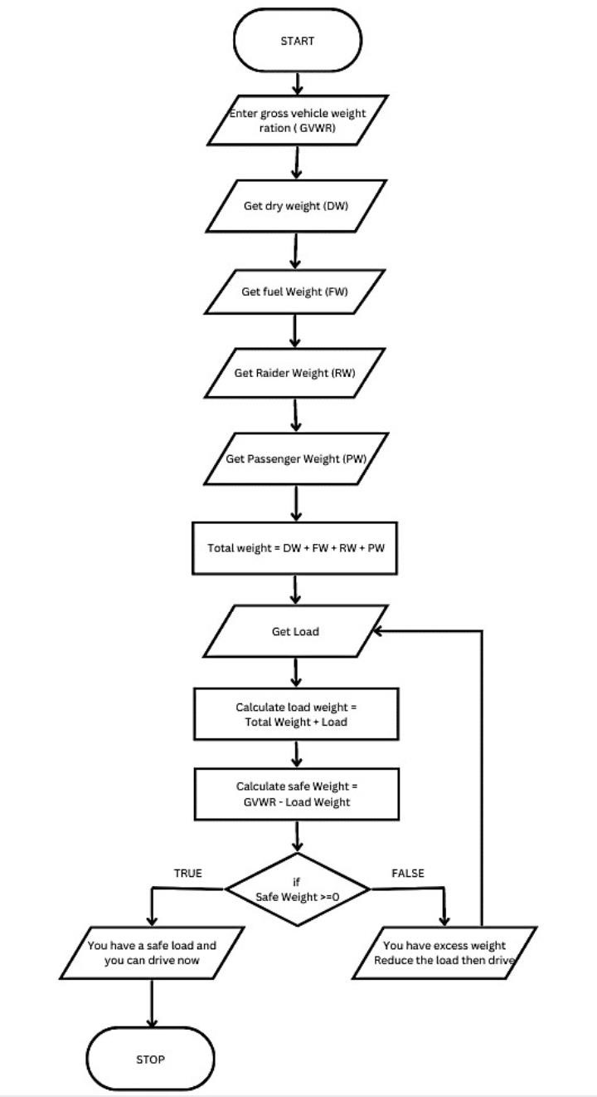

**Result:**

Thus the algorithm and the flowchart is written for the given problem.

# Expt no: 1 g Student Grade Analysis

**Aim:**

To draw a flowchart and write algorithm for calculating Students Grade analysis

**Algorithm:**

## Step 1: Start

**Step 2:** Read the no of Students: ‘N’

**Step 3:** Initialize i=1

**Step 4:** if i<=N, go to Step 5, False, Go to Step 15

**Step 5:** Read the m1, m2, m3 and Name of the Students

**Step 6:** Total=m1+m2+m3

**Step 7:** Average=Total/3

**Step 8:** If avg>=90 & avg<=100; go to step 8.1; else go to Step 9

**8.1:** Grade=0

**Step 9:** If avg>=75 & avg<90; go to step 9.1; else go to Step 10

**9.1:** Grade=A

**Step 10:** If avg >=50 & avg < 75; go to step 10.1; else go to Step 11

**10.1:** Grade=B

**Step 11:** If avg>=35 & avg<50, go to Step 11.1, else go to Step 12

**11.1:** Grade=C

**Step 12:** If avg<35; yes; go to step 12.1; No go to Step 13

**12.1:** Grade=D

**Step 13:** Increment I, i=i+1

**Step 14:** Print Name and Grade

## Step 15: Stop

**Flowchart:**

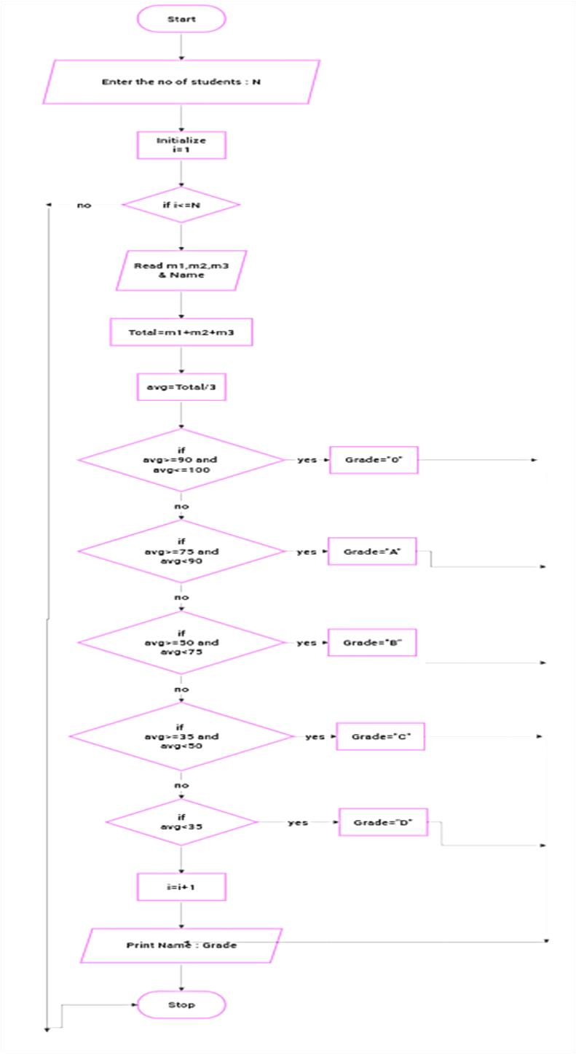

**Result:**

Thus the algorithm and the flowchart is written for the given problem.